Electrical Systems Notes:

- What is a series circuit?
  - A series circuit is a circuit with only one path
  - The current in a series circuit is the same everywhere
  - The voltage in a series circuit is not the same everywhere
  - To calculate the total resistance in a series circuit add up all the resistors.
  - Write the equation for the current:

- What is a parallel circuit?
  - A parallel circuit is a circuit with more than one path
  - The current in a parallel circuit is not the same everywhere
  - The voltage in a parallel circuit is the same everywhere. What ever the voltage of the battery is that’s the voltage everywhere in the circuit.
  - To calculate the current in one path of a parallel circuit take the voltage of the battery and divide it by the resistance in the path.

- What instruments are used to measure parts of a circuit?
  - An ammeter to measure current
  - A voltmeter to measure voltage

- What components are used in a circuit and what do they do? DRAW the symbols…
  - Resistor is anything that slows down electricity
  - Battery gives voltage and current to a circuit using a chemical reaction
  - Light bulb uses electricity to give us light
  - Sources like batteries to give us current and voltage
  - Conductors to connect different parts of the circuit
  - Circuit Breakers to protect the circuit, they turn off the circuit when too much current is flowing and they can be reset and reused
  - Fuses to protect the circuit, they turn off the circuit when too much current is flowing and they burn out and have to be replaced by a new one
  - Controllers are components that can control the flow of current in the circuit like switches, diodes, relays, and variable resistors
  - Switches are used to turn the flow of current on and off
  - Diodes only allow current to flow in one direction
  - Relays control the current with a secondary circuit
  - Variable resistor are resistors that you can change to control the flow of current
  - A load is anything that uses electricity in a circuit (e.g. resistors, blow dryers, tv, radio)

- What is Ohm’s law and the power law?
  - WRITE out the equations, units and cheat:

  - Resistance is anything that slows down electricity
  - Current is how fast electricity moves
  - Voltage is the force that pushes electricity
  - Power is how fast energy is being used in a circuit
  - When the voltage goes up the current goes up
  - When the resistance goes up the current goes down
  - When the current goes up the power goes up
  - When the voltage goes up the power goes up

- What factors change resistance?
  - When the temperature goes up then the resistance goes up
  - When the diameter or width of a wire goes down then the resistance goes up
  - When the length of a wire goes up the resistance goes up

- What are AC and DC currents?
  - AC current are current that are always changing from + to –
  - AC current comes from an outlet
  - DC current don’t change and stay the same
  - DC current comes from a battery

Electrical Systems Problems:
1. The diagram below shows a circuit with three different resistors, R₁, R₂, and R₃.
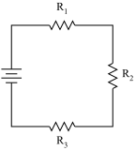
Which of the following equations should be used to calculate the total resistance, R_{T}, of the circuit?
 | A.
 | B.
 | C. | 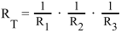
 | D. | 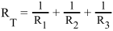
2. The voltage across a resistor in a circuit is 6 V and the current is 0.25 A.What is the resistance?
 | A. | 0.04 Ω
 | B. | 1.5 Ω
 | C. | 9 Ω
 | D. | 24 Ω

3.
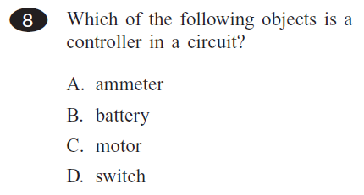
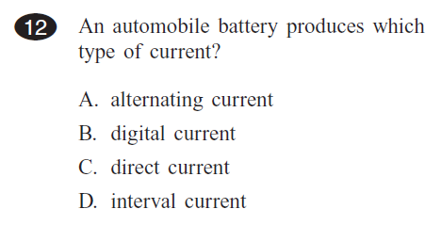
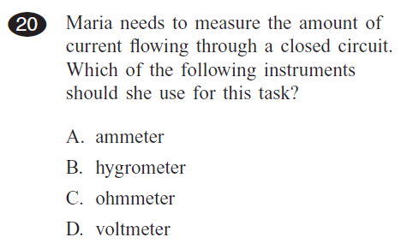
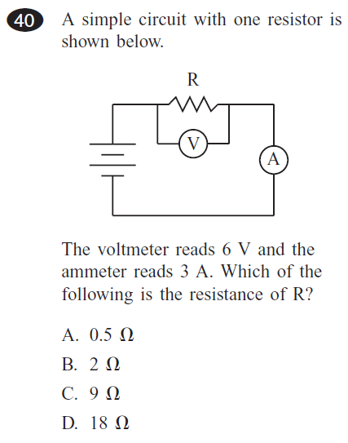
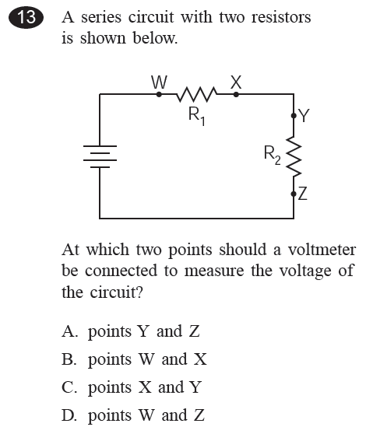
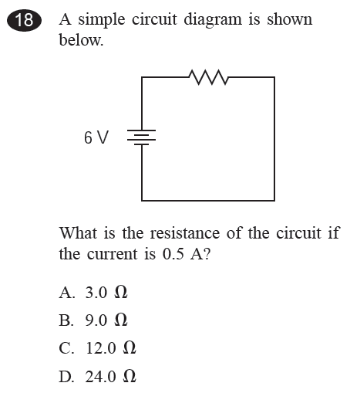
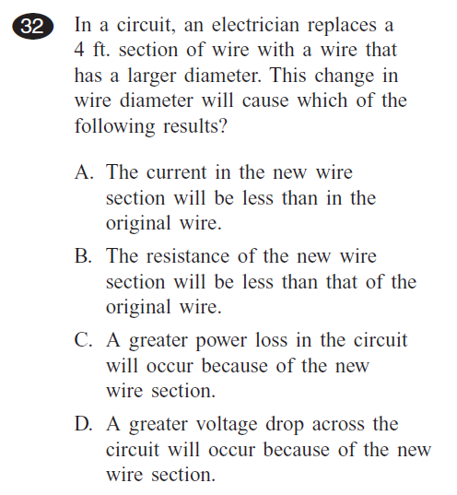
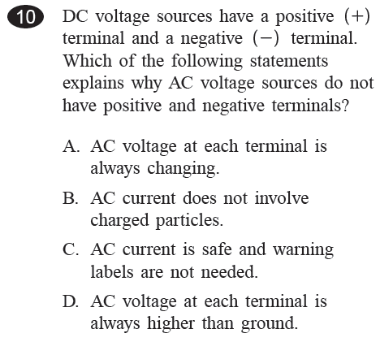
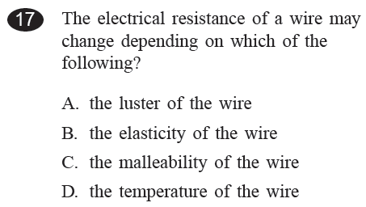
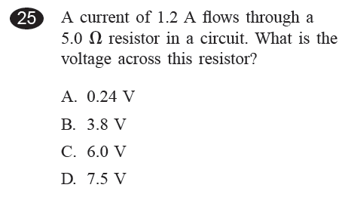
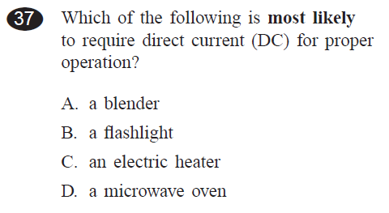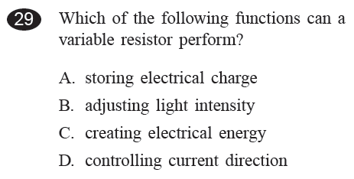
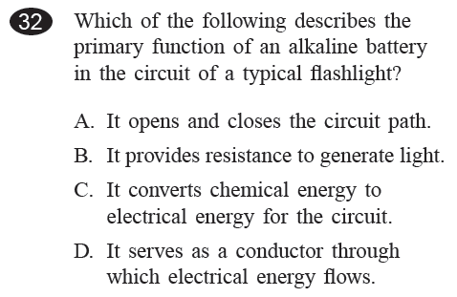
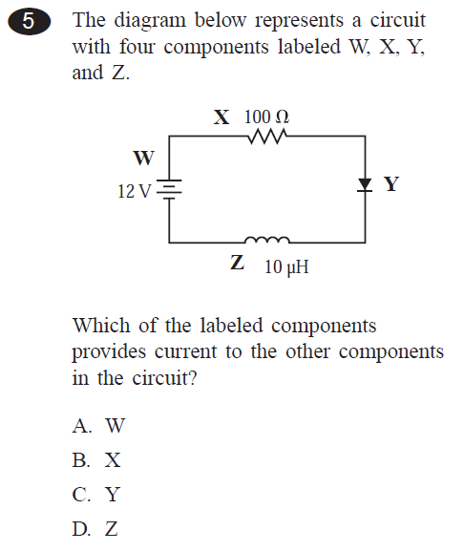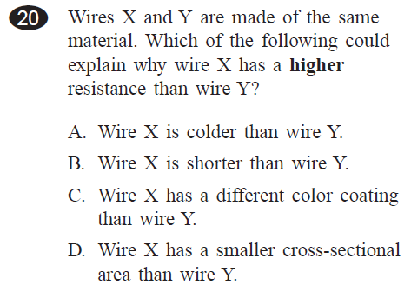
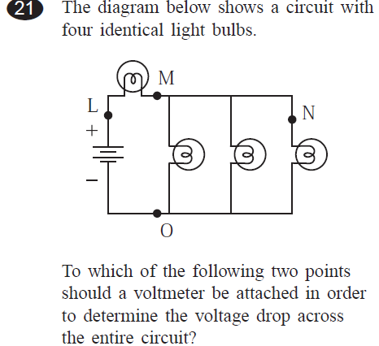
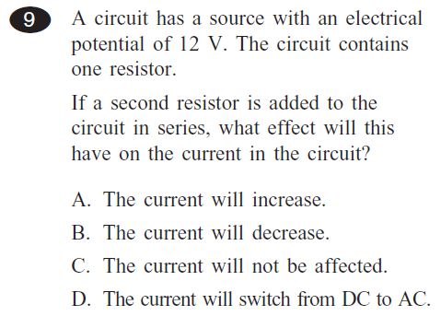
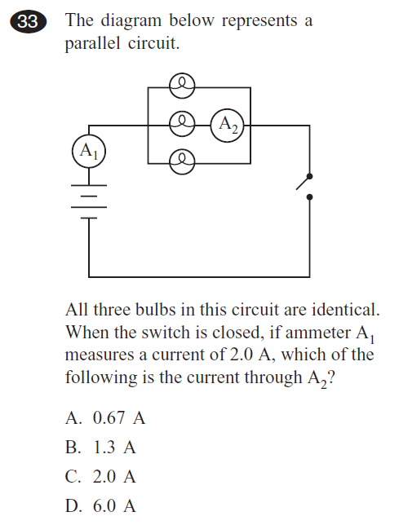
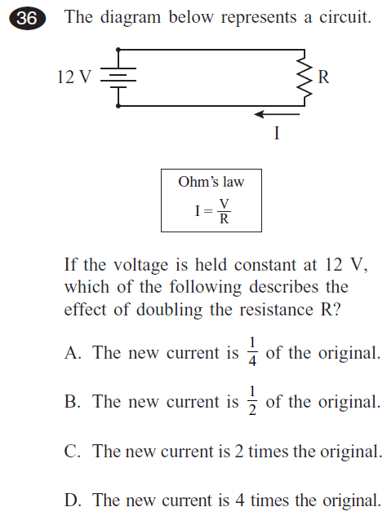
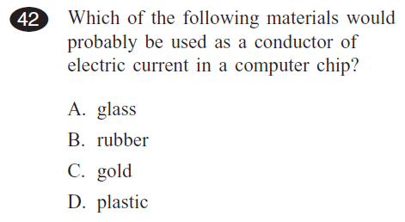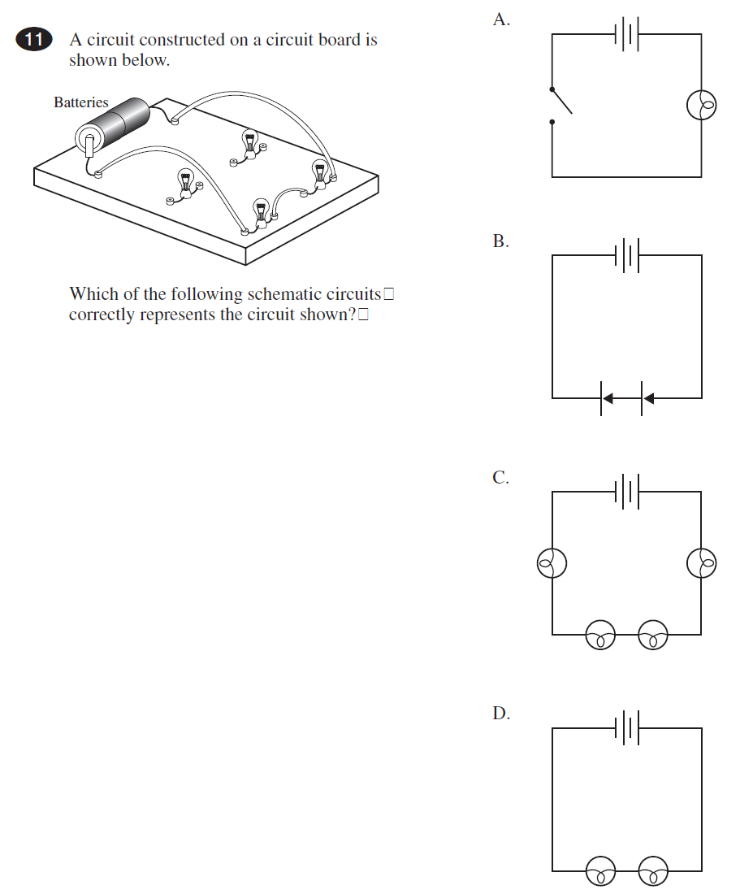

Open Response Questions

1. A diagram for a simple circuit is shown below.
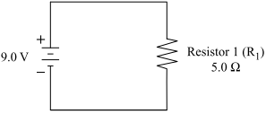

Suppose a second resistor (R₂), with a resistance of 7.0 Ω, is added to the circuit in series.
- Draw the diagram for the series circuit with the two resistors. Label the components of the new circuit.

- Calculate the total amount of current in the new circuit. Show your calculations and include units in your answer.

- Calculate the potential difference (voltage) across each resistor, R₁ and R₂, in the new circuit. Show your calculations and include units in your answer.

2. A battery, a variable resistor, and a light bulb are shown in the circuit below.
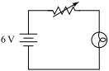

- Explain the function of the battery in the circuit.

- Describe what will happen to the light bulb if the variable resistor is set at 0Ω.

- If the variable resistor is set at 18Ω, calculate the current in the circuit. Assume the resistance of the light bulb is 12Ω. Show your calculations and include units in your answer.

- Describe what will most likely happen to the light bulb if the variable resistor’s resistance is increased. Explain your answer.

